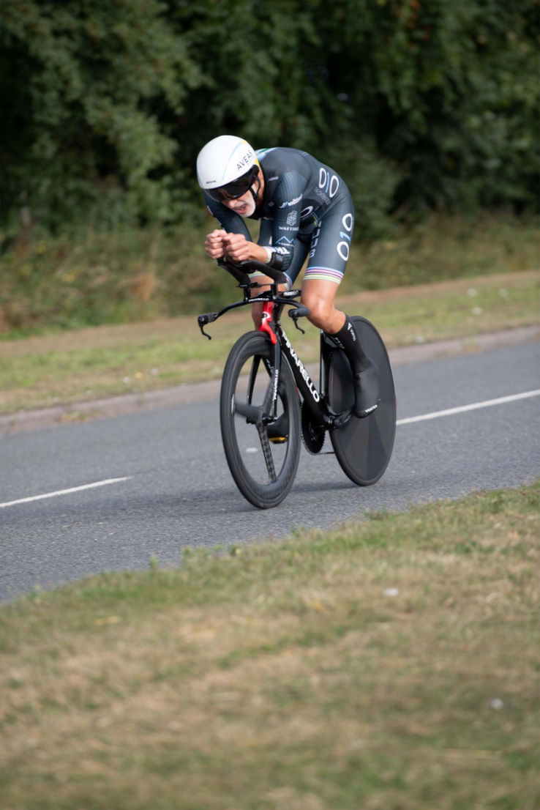
S V T T A
15 Miles Speed Family Trophy
24th September 2023
Organised by SVTTA
Promoted for and on behalf of Cycling Time Trials
under its Rules and Regulations

SCOTTISH VETERANS TIME TRIALS ASSOCIATION

15 Miles
(Speed Family Trophy)

Promoted by George McLaughlan, 151 Netherton Road, Wishaw

24th September 2023 – 8.00 am start

Course WM.15/01
Promoted for and on behalf of Cycling Time Trials
under their Rules and Regulations

Event Secretary Contact Details Timekeepers
George McLaughlan Mhairi Laffoley
151 Netherton Road Catriona Stirling
Wishaw
ML2 0AR
Email: gmclaughlan41@gmail.com
PRIZES

RIDERS’ NOTES
- HEADQUARTERS

Cambusbarron Community Hall, Cambusbarron, FK7 9NU (Open from 7am)

- PARKING –

Some spaces at the HQ and we have been given permission to use parking at the Bowling Club otherwise parking is on-street (please be careful not to block drives etc). There will be NO parking at either start or finish

- REFRESHMENTS
There will be some light refreshments at HQ.

- SIGNING ON AND OFF

HQ will be open from 7am for sign on/off. Numbers will be available at HQ. It is compulsory for all riders to sign on AND sign out after completing the event. Do not forget to sign out or you may be disqualified from the event.

- Start:

The start is on the A811 approximately ½ mile to the East of the Kersebonny Road end, Cambusbarron. It is approx. 1 ½ miles from the event HQ.

The start is accessed from Cambusbarron village by turning right from the HQ entrance, proceeding into the village, turning right down Mill Brae after about a quarter of a mile and left onto Mill Road, which leads to Kersebonny Road. Turn right at the end of the Kersebonny Road (please take extra care as you will be turning over the course/traffic and riders will already be underway) and head East towards Stirling Castle. Cross the motorway flyover and the start is approx. 320 m west of Clay Toll Roundabout.
Please DO NOT warm up on the course but note that you will need to cross through the finish line to make your way to the start. If you are on the way to your start DO NOT adopt a racing position as you go through the finish area to avoid confusion for the timekeeper and take care not to interfere with those racing.
- Map from HQ to Start

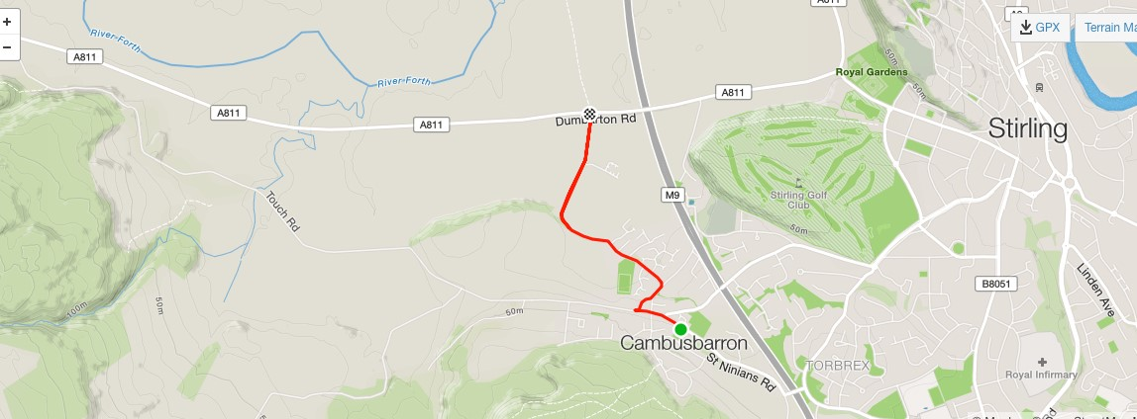

- COURSE DETAILS
The course is an out and back along the A811. From the start it heads west to turn at the Kippen roundabout. There will be Marshals at this point. They are not allowed to stop traffic so riders must adhere to highway code when negotiating the roundabout. Retrace along the A811 crossing over the motorway flyover and finish at the entrance to Falleninch Farm. On your return to the HQ please be considerate whilst riding on A811 back to Kersebonny Road as there will be other riders who have just started their race.
Please note that the event is on an “A” class road and therefore can be busy with traffic – care should be taken at all times and the Highway Code adhered to.

- SAFETY AND LOCAL REGULATIONS
Warming Up - Please DO NOT warm up on the course once the event has started but note that you will need to cross through the finish line to make your way to the start. If you are on the way to your start DO NOT adopt a racing position as you go through the finish area to avoid confusion for the timekeeper and take care not to interfere with those racing. Also on returning to HQ when you finish please make sure you do not interfere with those racing.
Cycling Time Trials now require that all riders must wear a hard shell helmet that meets an internationally accepted safety standard. (CTT regulation 15)
Working rear and front lights, either flashing or constant, must be fitted to machines in a position visible to road users and must be active whilst the machine is in use. (CTT regulations 14(i) and 14(j))

- RESULTS AND PRESENTATION - There will be a prize presentation after the event.

- START SHEET

The start sheet should include the following columns.

No | Start  Time | Name | Club | Bike (TT, Road, Trike) | Age | Age Adj
1 | 8.01 | George Adam | SVTTA
2 | 8.02 | Thomas Cummings | Fife Century RC
3 | 8.03 | George Skinner | Royal Albert
4 | 8.04 | Jennifer Nicol | Velo Club Vitesse
5 | 8.05 | Andrew Wilson | St Christopher’s CC
6 | 8.06 | Elizabeth Clayton | RT23
7 | 8.07 | Chris White | Fife Century RC
8 | 8.08 | Lindsay Foster | Ayrodynamics Tri
9 | 8.09 | Sarah Emslie | SVTTA
10 | 8.10 | Paul Wynne | Kinross CC
11 | 8.11 | Gail Paterson | Dumfries CC
12 | 8.12 | James Smith | Glasgow Nightingale
13 | 8.13 | Rachael Maxwell | Border City Wheelers
14 | 8.14 | Gary Longhurst | Stirling Bike Club
15 | 8.15 | Liz Ball | Valley Striders
16 | 8.16 | Miriam Rennet | Kinross CC
17 | 8.17
18 | 8.18 | Lorna/John Lumley | Ayrodynamics Tri | Tandem
19 | 8.19
20 | 8.20 | Isobel Fletcher/  Allan MacLean | VC Glasgow South | Tandem
21 | 8.21 | Robert Holmes | Kinross CC
22 | 8.22 | Carol Middleton | Ythan CC
23 | 8.23 | Bill Maxwell | Border City Wheelers
24 | 8.24 | Derrick John MacNish | Inverclyde Velo
25 | 8.25 | Steve Donaldson | Fullarton Wheelers
26 | 8.26 | Robert Brown | EH Star Cycling
27 | 8.27 | Valerie Martin | Dooleys RT
28 | 8.28 | Gerard McGuire | Pentland Velo
29 | 8.29 | Neil McLeod | SVTTA
30 | 8.30 | Alex McPhee | Dooleys RT
31 | 8.31 | Stephen Beecher | West Lothian Clarion
32 | 8.32 | Iain Wilson | Musselburgh RCC
33 | 8.33 | Gordon Murdoch | St Christopher’s CC
34 | 8.34 | Margaret McMillan | Deeside Thistle
35 | 8.35 | John Leal | Deeside Thistle
36 | 8.36 | Patricia Baird | Ecosse Performance CC
37 | 8.37 | Bud Johnston | SVTTA
38 | 8.38 | Clifford Degraff | Velo Club Cumbria
39 | 8.39 | Alex Munro | SVTTA
40 | 8.40
41 | 8.41 | Michael Perkins | Eat Plants Not Pigs
42 | 8.42 | Jon Fairclough | Kelso Wheelers
43 | 8.43 | Carolyn Chambers | North Argyll CC
44 | 8.44 | Thomas McNulty | SVTTA
45 | 8.45 | Brian Nicol | Velo Club Vitesse
46 | 8.46 | Andrew Yule | Deeside Thistle
47 | 8.47 | Kevin Lackie | RT23
48 | 8.48 | Ian Dobbie | West Lothian Clarion
49 | 8.49 | Mike Giles | Ythan CC
50 | 8.50 | Andrew Bruce | Vanelli Project GO
51 | 8.51 | Ian Elliot | Hawick CC
52 | 8.52 | Alastair Pell | Glasgow Nightingale
53 | 8.53 | James Muir | Glasgow Nightingale
54 | 8.54 | David Henderson | EH Star Cycling
55 | 8.55 | Graham Jones | Edinburgh RC
56 | 8.56 | Alan MacIntyre | Coatbridge Clarion
57 | 8.57 | Steven Purdie | Glasgow Green CC
58 | 8.58 | Warren Crombie | Musselburgh RCC
59 | 8.59 | Derek McMillan | SVTTA
60 | 9.00 | Carlos Riise | Shetland Wheelers
61 | 9.01
62 | 9.02 | Michael Curran | Ayr Roads CC
63 | 9.03 | Sean Quinn | Law Wheelers
64 | 9.04 | Stephen Spellacy | Dumfries CC
65 | 9.05 | James Cusick | Dooleys RT
66 | 9.06 | Richard Sanderson | Kinross CC
67 | 9.07 | Cameron Fraser | Sigma Sports/ Cannondale RT
68 | 9.08 | Craig O’Brien | Glasgow Wheelers
69 | 9.09 | Basil Monks | Edinburgh RC
70 | 9.10 | Angus Wilson | Dundee Thistle
71 | 9.11 | Sandy Waller | Edinburgh RC
72 | 9.12 | Marc Anderson | GTR Return to Life
73 | 9.13 | Robert Friel | Vanelli Project GO
74 | 9.14 | Alastair McNicol | Dooleys RT
75 | 9.15 | Douglas Watson | GTR Return to Life

